A Divide-and-conquer Approach to Fragment Assembly

Hasan H. Otu and Khalid Sayood

BIOINFORMATICS, Vol. 19, No. 1, pp. 22-29, 2003
Abstract
Most existing fragment assembly techniques follow the overlap-layout-consensus approach. This framework requires extensive computation in each phase and becomes inefficient with increasing number of fragment.

- Introduction
The goal in fragment assembly is to reconstruct the target from the collection of fragment.
A formal definition of the Sequence Reconstruction Problem (SRP) was the first attempt at formulating fragment assembly. The objective in SRP is to find the shortest consensus sequence S, which contain each fragment or its reverse complement within a small edit distance. The SRP approach provides a common framework for fragment assembly by dividing the problem into three phases: overlap, layout and consensus.

- Methods and algorithms
Most existing algorithms puts a significant among of computational burden in the overlap phase. This paper significantly reduce the computational burden by clustering the fragments before exploring overlaps.
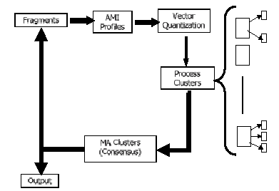

  - Average mutual information
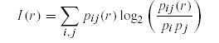
(2) Clustering
Given N vectors 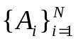, the algorithm obtains J clusters by trying to minimize the total distortion 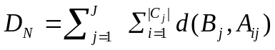 where 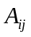 is the ith vector in the jth cluster,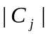 is the cardinality of the cluster 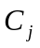,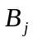 is the representative vector in cardinality of the cluster.

(3) Processing the clusters
    - Clustering error
A clustering error occurs if fragments in a given cluster belong to non-overlapping regions of the target sequence.
    - Multiple alignment
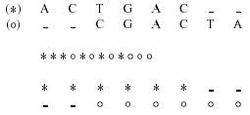

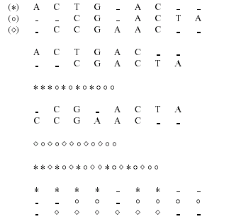

- Conclusions

Created by: Chia-Chang Wang
Date: Nov. 28, 2003

